Bench Brewery

Assigned to: Natasha

Reporting Month: March 2025

# Results and Discussion

# Appendix A: SGS Tables & Graphs

## Sewage Table

|  |  |  |  |  |  |  |
| --- | --- | --- | --- | --- | --- | --- |
| Date | cBOD5 | TSS | TKN | NO3 | NO2 | TN |
| 23-Jan-25 | 10 | 7 | 0.5 | 8.53 | 0.03 | 9.06 |
| 20-Feb-25 | 10 | 2 | 8 | 7.21 | 0.28 | 15.49 |
| 20-Mar-25 | 10 | 10 | 5.3 | 5.75 | 0.33 | 11.38 |

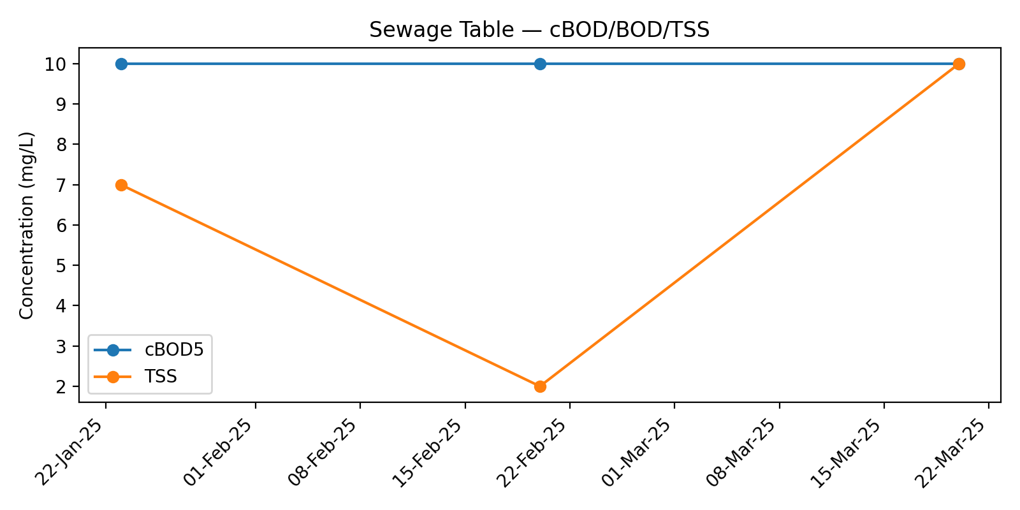

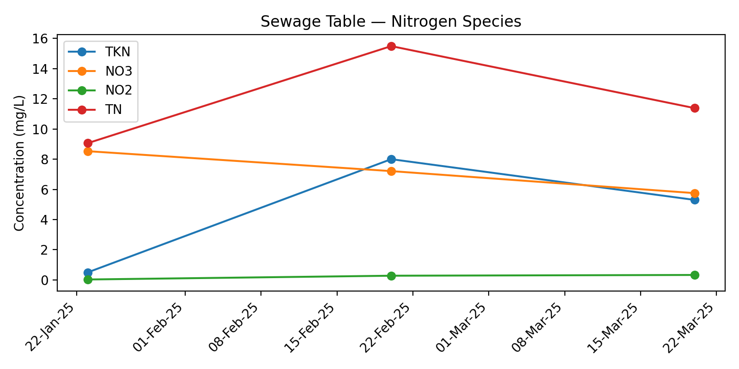

## Biofilter Effluent Table

|  |  |  |  |  |  |  |  |
| --- | --- | --- | --- | --- | --- | --- | --- |
| Date | cBOD5 | TSS | TKN | TAN | NO3 | NO2 | TN |
| 23-Jan-25 | 4 | 2 | 0.5 | 0.1 | 16.1 | 0.03 | 16.63 |
| 20-Feb-25 | 4 | 2 | 7.3 | 6.6 | 8.59 | 1.46 | 17.35 |
| 20-Mar-25 | 4 | 2 | 0.5 | 0.1 | 13.6 | 0.15 | 14.25 |

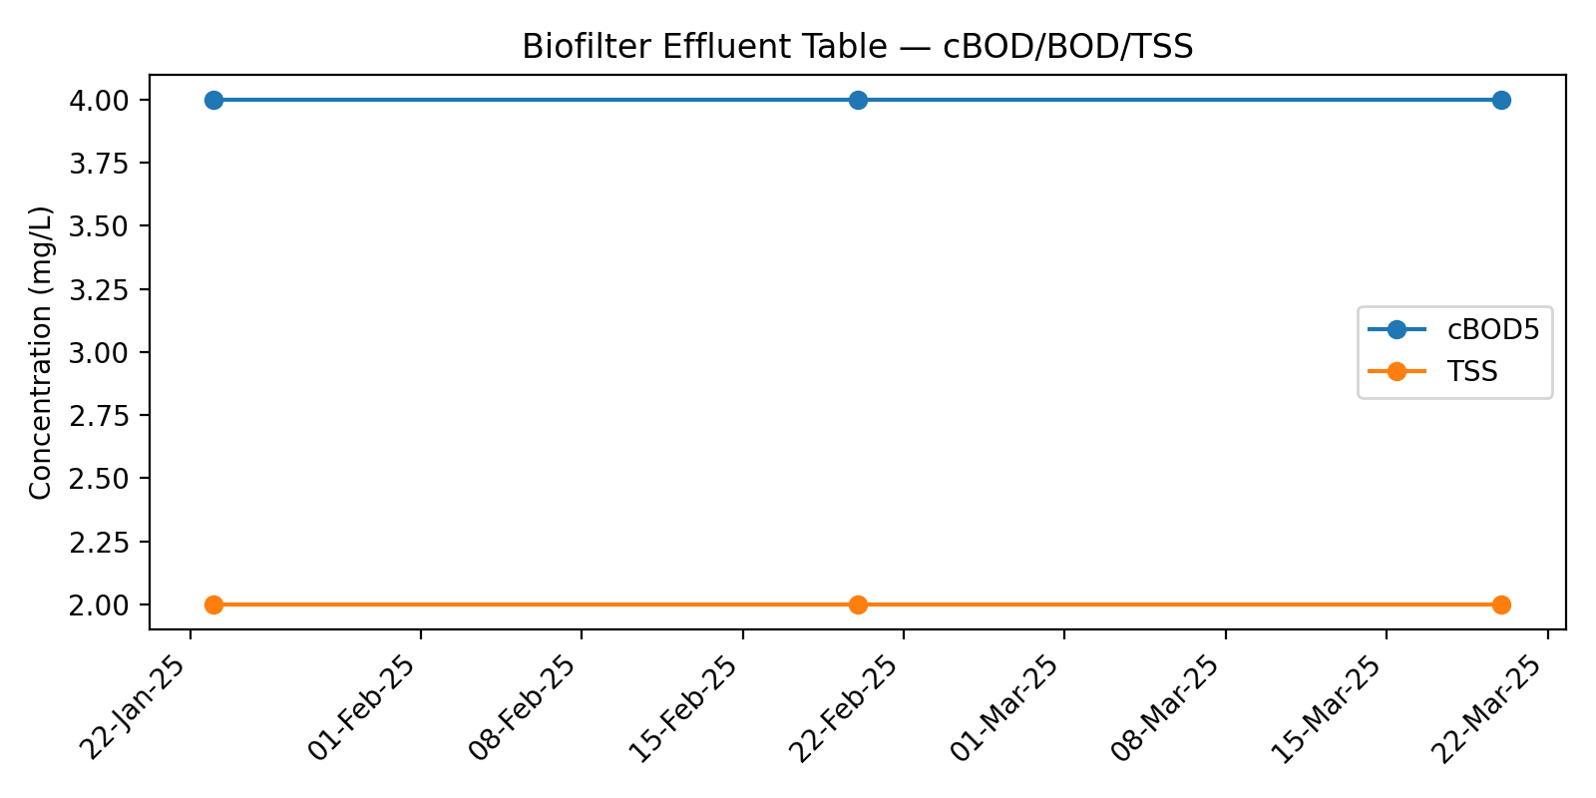

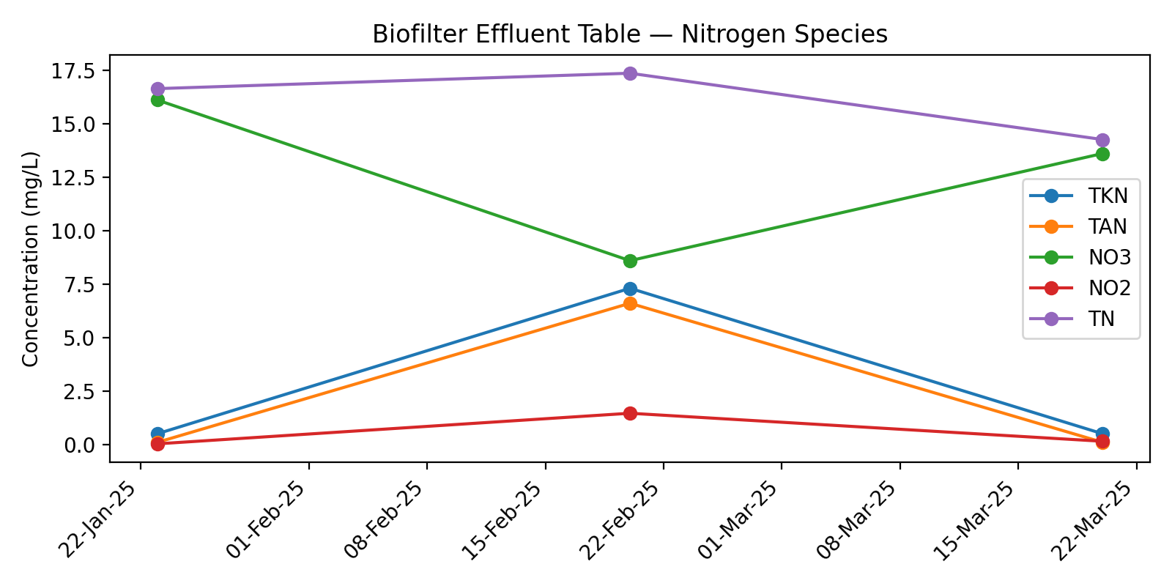

## WaterNOx Effluent Table

|  |  |  |  |  |  |  |  |
| --- | --- | --- | --- | --- | --- | --- | --- |
| Date | cBOD5 | TSS | TKN | TAN | NO3 | NO2 | TN |
| 23-Jan-25 | 10 | 2 | 0.5 | 0.1 | 0.23 | 0.03 | 0.36 |
| 20-Feb-25 | 4 | 3 | 9 | 8.4 | 0.48 | 0.5 | 9.38 |
| 20-Mar-25 | 10 | 4 | 2.1 | 1.7 | 0.06 | 0.03 | 1.79 |

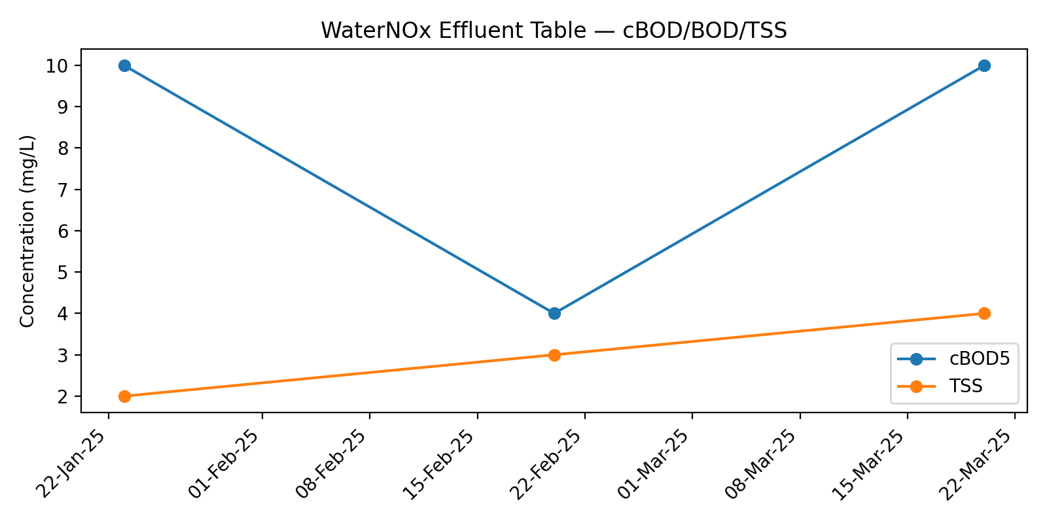

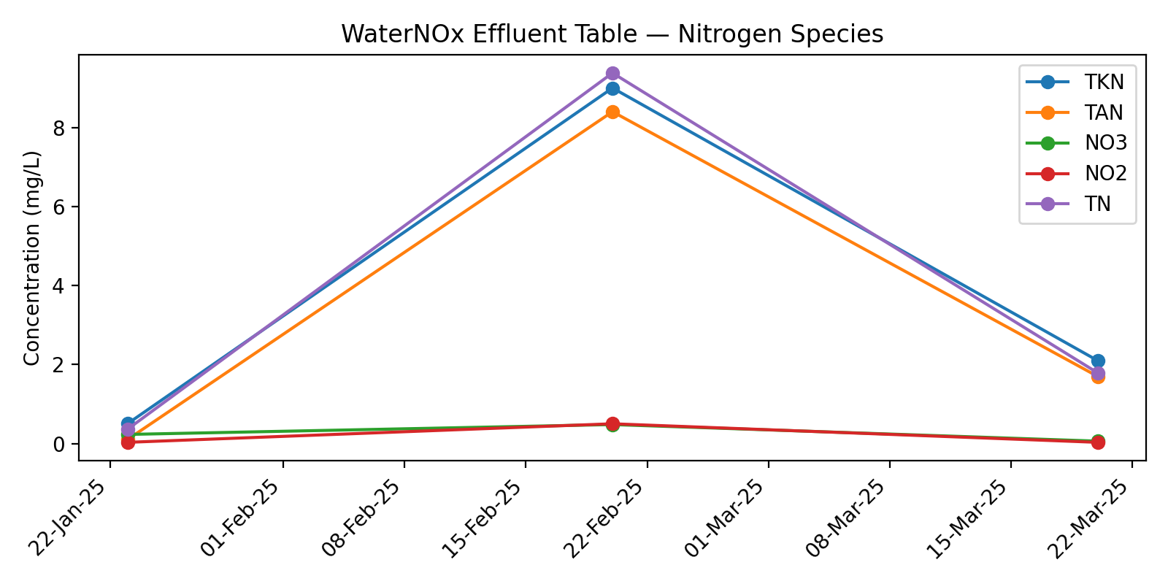

# Appendix B: Flow Data — January 2025

## Jan 25

|  |  |  |  |
| --- | --- | --- | --- |
| Date | Disposal 1 (L/day) | Disposal 2 (L/day) | Total Daily Flow (L/day) |
| 01-Jan-25 | 0 | 0 | 0 |
| 02-Jan-25 | 0 | 0 | 0 |
| 03-Jan-25 | 0 | 0 | 0 |
| 04-Jan-25 | 0 | 0 | 0 |
| 05-Jan-25 | 0 | 0 | 0 |
| 06-Jan-25 | 0 | 0 | 0 |
| 07-Jan-25 | 0 | 0 | 0 |
| 08-Jan-25 | 0 | 0 | 0 |
| 09-Jan-25 | 0 | 0 | 0 |
| 10-Jan-25 | 0 | 0 | 0 |
| 11-Jan-25 | 0 | 0 | 0 |
| 12-Jan-25 | 0 | 0 | 0 |
| 13-Jan-25 | 0 | 0 | 0 |
| 14-Jan-25 | 0 | 0 | 0 |
| 15-Jan-25 | 0 | 0 | 0 |
| 16-Jan-25 | 0 | 0 | 0 |
| 17-Jan-25 | 0 | 0 | 0 |
| 18-Jan-25 | 0 | 0 | 0 |
| 19-Jan-25 | 0 | 0 | 0 |
| 20-Jan-25 | 0 | 0 | 0 |
| 21-Jan-25 | 0 | 0 | 0 |
| 22-Jan-25 | 0 | 0 | 0 |
| 23-Jan-25 | 115 | 108 | 223 |
| 24-Jan-25 | 0 | 0 | 0 |
| 25-Jan-25 | 0 | 0 | 0 |
| 26-Jan-25 | 0 | 0 | 0 |
| 27-Jan-25 | 0 | 0 | 0 |
| 28-Jan-25 | 0 | 0 | 0 |
| 29-Jan-25 | 0 | 0 | 0 |
| 30-Jan-25 | 2944 | 4151 | 7095 |
| 31-Jan-25 | 11903 | 11297 | 23200 |
| Total Flow (L) |  |  | 30518 |
| Average Flow (L/day) |  |  | 984 |

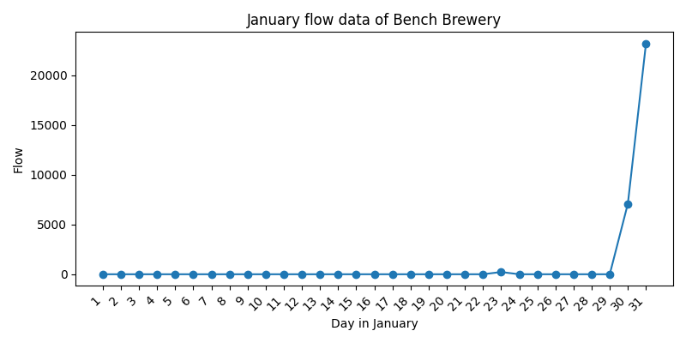

# Appendix C: Site Notes

# Appendix B: Flow Data — February 2025

## Feb 25

|  |  |  |  |
| --- | --- | --- | --- |
| Date | Disposal 1 (L/day) | Disposal 2 (L/day) | Total Daily Flow (L/day) |
| 01-Feb-25 | 1303 | 1832 | 3135 |
| 02-Feb-25 | 0 | 0 | 0 |
| 03-Feb-25 | 663 | 625 | 1288 |
| 04-Feb-25 | 9744 | 8253 | 17997 |
| 05-Feb-25 | 602 | 617 | 1219 |
| 06-Feb-25 | 0 | 0 | 0 |
| 07-Feb-25 | 0 | 0 | 0 |
| 08-Feb-25 | 0 | 0 | 0 |
| 09-Feb-25 | 9242 | 9342 | 18584 |
| 10-Feb-25 | 660 | 1231 | 1891 |
| 11-Feb-25 | 0 | 0 | 0 |
| 12-Feb-25 | 0 | 0 | 0 |
| 13-Feb-25 | 0 | 0 | 0 |
| 14-Feb-25 | 0 | 0 | 0 |
| 15-Feb-25 | 9978 | 7916 | 17894 |
| 16-Feb-25 | 656 | 617 | 1273 |
| 17-Feb-25 | 0 | 0 | 0 |
| 18-Feb-25 | 0 | 0 | 0 |
| 19-Feb-25 | 0 | 0 | 0 |
| 20-Feb-25 | 49 | 322 | 371 |
| 21-Feb-25 | 9292 | 8866 | 18158 |
| 22-Feb-25 | 663 | 1200 | 1863 |
| 23-Feb-25 | 622 | 602 | 1224 |
| 24-Feb-25 | 651 | 0 | 651 |
| 25-Feb-25 | 606 | 617 | 1223 |
| 26-Feb-25 | 644 | 591 | 1235 |
| 27-Feb-25 | 391 | 586 | 977 |
| 28-Feb-25 | 249 | 610 | 859 |
| Total Flow (L) |  |  | 89842 |
| Average Flow (L/day) |  |  | 3209 |

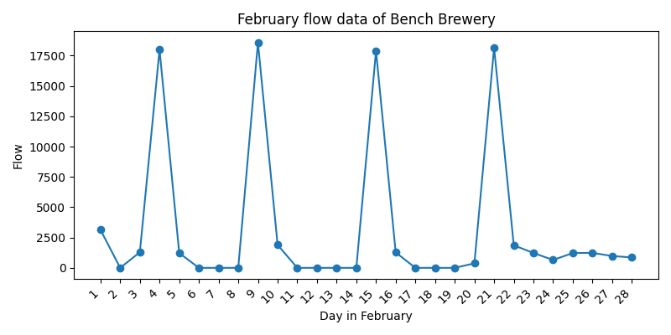

# Appendix C: Site Notes

# Appendix B: Flow Data — March 2025

## Mar 25

|  |  |  |  |  |
| --- | --- | --- | --- | --- |
| Date | Disposal 1 (L/day) | Disposal 1 (L/day) | Disposal 2 (L/day) | Total Daily Flow (L/day) |
| 01-Mar-25 | 1238 | 4083255 | 605 | 1843 |
| 02-Mar-25 | 0 | 4083838 | 583 | 583 |
| 03-Mar-25 | 637 | 4083838 | 0 | 637 |
| 04-Mar-25 | 632 | 4085034 | 1196 | 1828 |
| 05-Mar-25 | 613 | 4085034 | 0 | 613 |
| 06-Mar-25 | 602 | 4085624 | 590 | 1192 |
| 07-Mar-25 | 629 | 4086207 | 583 | 1212 |
| 08-Mar-25 | 0 | 4086790 | 583 | 583 |
| 09-Mar-25 | 621 | 4087388 | 598 | 1219 |
| 10-Mar-25 | 1219 | 4087986 | 598 | 1817 |
| 11-Mar-25 | 0 | 4088564 | 578 | 578 |
| 12-Mar-25 | 628 | 4088564 | 0 | 628 |
| 13-Mar-25 | 622 | 4089730 | 1166 | 1788 |
| 14-Mar-25 | 601 | 4089730 | 0 | 601 |
| 15-Mar-25 | 610 | 4090312 | 582 | 1192 |
| 16-Mar-25 | 632 | 4090903 | 591 | 1223 |
| 17-Mar-25 | 0 | 4091474 | 571 | 571 |
| 18-Mar-25 | 617 | 4092064 | 590 | 1207 |
| 19-Mar-25 | 1220 | 4092658 | 594 | 1814 |
| 20-Mar-25 | 49 | 4092773 | 115 | 164 |
| 21-Mar-25 | 614 | 4093344 | 571 | 1185 |
| 22-Mar-25 | 655 | 4094571 | 1227 | 1882 |
| 23-Mar-25 | 0 | 4094571 | 0 | 0 |
| 24-Mar-25 | 1231 | 4095188 | 617 | 1848 |
| 25-Mar-25 | 613 | 4095748 | 560 | 1173 |
| 26-Mar-25 | 0 | 4096319 | 571 | 571 |
| 27-Mar-25 | 625 | 4096906 | 587 | 1212 |
| 28-Mar-25 | 1280 | 4097508 | 602 | 1882 |
| 29-Mar-25 | 0 | 4097508 | 0 | 0 |
| 30-Mar-25 | 648 | 4098669 | 1161 | 1809 |
| 31-Mar-25 | 606 | 4099252 | 583 | 1189 |
| Total Flow (L) |  |  |  | 34044 |
| Average Flow (L/day) |  |  |  | 1098 |

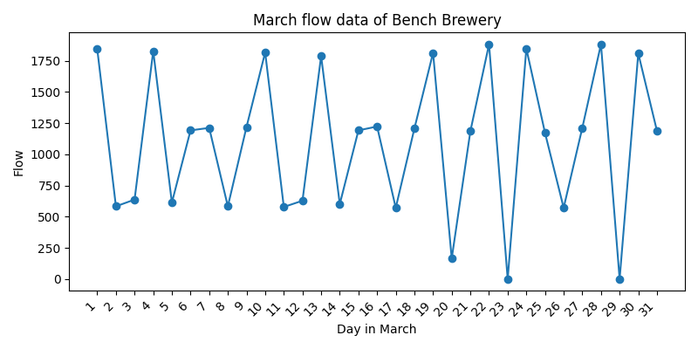

# Appendix C: Site Notes